This project is funded by the European Union | “ALTER - Active Local Territories for Economic development of Rural Areas”  GRANT PROGRAMME

Civil Society

Capacity Building and Advocacy

Grant Program

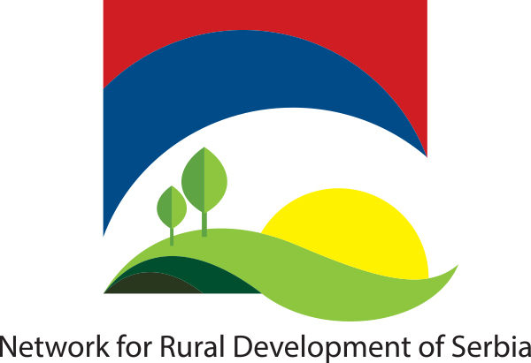 |  |  |  | 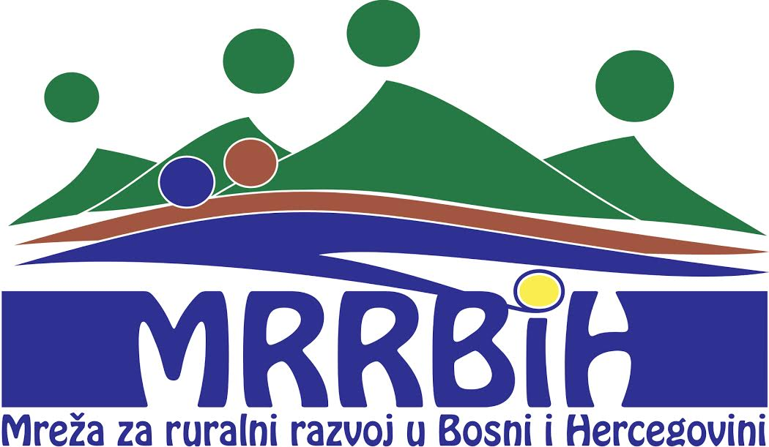 |  | 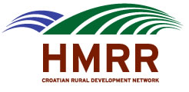
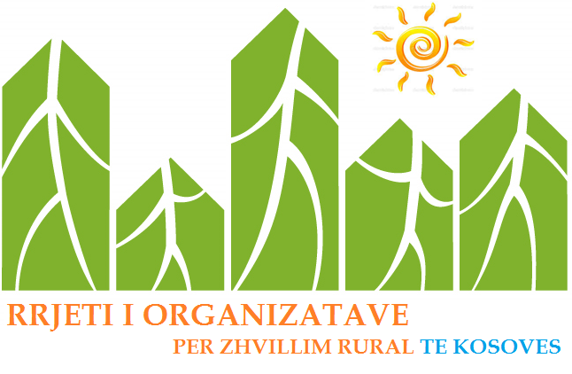 | 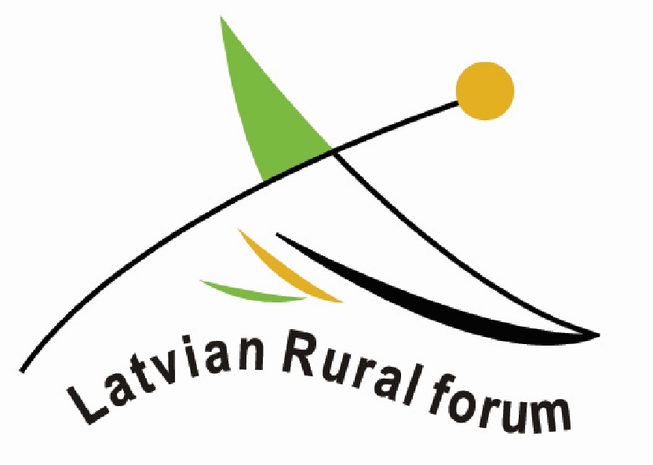 |  | 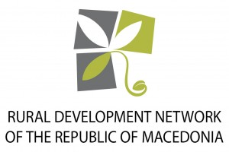 |  |  |  | 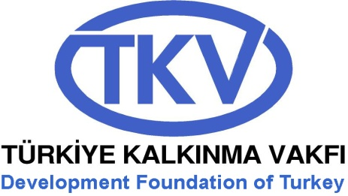
This document has been produced with the financial assistance of the European Union. The contents of this document are the sole responsibility of Network for Rural Development of Serbia and can under no circumstances be regarded as reflecting the position of the European Union.

Content
1. ALTER - Active Local Territories for Economic development of Rural Areas 3
1.1. Purpose of the Program 4
1.2. Expected Outcomes of the Action 5
2. Civil Society Capacity Building and Advocacy Grant Program 6
2.1 Goals and Priorities of the Program 6
2.2 Project Indicators 6
2.3 General Outline 7
2.4 Eligibility 7
Partnerships 7
2.5 Thematic area 8
2.6 Eligibility of Expenses 8
2.6.1 Actions Eligible for Funding 8
2.6.2 Actions Non-eligible for Funding 9
2.7 Type and Amount of the Grant 10
2.8 Geographical Reach 10
2.9 Timeline of the Grant 11
2.10 Visibility 11
3. Applications 11
3.1 How to Apply 11
3.2 Selection Process and Scoring 11
3.2.1 Scoring 12
3.2.2 Evaluation Grid 12
3.3 Grant Award Contract and Payments 13
3.4 Reporting 13
3.5 Monitoring and Evaluations 14

ALTER - Active Local Territories for Economic development of Rural Areas
Key issues, relevant to sustainable rural development, were as follows:
Involvement of stakeholders; Governments in the seven countries have all, to varying degree, sought to involve stakeholders in the process of preparing strategies for agriculture and rural development. The main focus has been upon information and consultation, by means such as seminars and invitations to the general public to comment. Some groundwork has been laid for the movement onwards into participation, for example the activity in helping to draft policies, and even partnership. But large numbers of stakeholders cannot connect to policy-making processes. The project will use advocacy, networking and capacity building to enable more stakeholders to connect to these processes.
Activism of stakeholders; On their side, rural stakeholders should not stand back and expect government to take the whole lead in connecting with them. They should be assertive, willing to work with each other, ready to join or form associations. Individually or collectively, they should press for opportunities to take part in shaping, implementing and monitoring policies, and respond to those opportunities. The project will promote cooperation among rural stakeholders.
Powerless citizens; Many rural regions in the 7 countries have narrowly-based rural economies, low average incomes, unemployment, seasonal labour, out-migration of young people, high average age among those who remain. They suffer from poverty, and from social exclusion, particularly among minorities. There are hundreds of thousands of small farms, disadvantaged by limited size, lack of capital, weak bargaining power and limited markets. If their voice is not heard, the number of such farms will fall drastically in number, causing grave weakening of rural economies and communities, unless rural economies are diversified before they are open to the full shock of EU competition. The project will support marginalised groups to express their voice and increase their presence in community development processes.
Growth points; Rural areas in the applicant countries offer examples of lively rural initiatives, active and successful leaders, both men and women. They provide jobs, and bring money into the local economy. Some of them have been elected to municipalities, and act as managers of municipal development programmes. These are crucial growth points in rural development. That raises the key issue of replicability … how do we find and encourage more such ‘fiery spirits’, what climates of policy, funding, regulation, credit etc. are needed in order to stimulate initiative? The project will seek to find answers to these questions. Continued and strengthened networking at all levels; Networking is needed at all levels, between and within countries. It must include networking and cooperation between governments, in order to exchange experience in development processes and to achieve cross-border cooperation. In the Balkans, this cooperation already includes the effective activity of the SWG, with which the applicant CSO networks already have close cooperation. The project will complement such networking among governments by promoting effective networking among other categories of stakeholder. Notably, it will aim to help village communities to share experience of practical local action and to raise the rural voice at municipal, regional and national level; LEADER groups and other sub-regional partnerships to exchange experience and to exercise their collective influence on the whole development process; and CSOs to raise their profile and enhance the capability of civil society in social and environmental fields.
Within this context, the Action titled Active Local Territories for Economic development of Rural Areas aims to stimulate an enabling legal and financial environment for civil society, as well as to empower civil society to be effective and accountable independent actors, and to improve their capacity to dialogue with Governments influencing policy and decision making processes in sustainable development of rural communities and holding them accountable for their performance towards citizens and society at large.
The Action has officially started in December 2015 and has a duration of 40 months It involves seven IPA beneficiaries and two partners from EU countries; namely Albania, Bosnia and Herzegovina, Macedonia, Montenegro, Kosovo*, Serbia, Turkey, Croatia and Latvia. The project partners are:
- Network for Rural Development of Serbia, Serbia as the project coordinator;
- Development Foundation of Turkey, Turkey;
- Network For Rural Development of Montenegro, Montenegro;
- Network for Rural Development of Macedonia, Macedonia;
- Network for Rural Development in Bosnia and Herzegovina, Bosnia and Herzegovina;
- Institue for Democacy and Mediation, Albania;
- Network of Organisation for Rurad Development of Kosovo, Kosovo;
- Croatian Network for Rural Development, Croatia;
- Latvian Rural Forum, Latvia.
Within the Action, capacity building of civil society organizations (CSOs) from each of the seven countries is aimed via awarding them financial support. Consequently, beneficiary CSOs will increase their knowledge and technical background to provide support sustainable community development, based on the local resources and inter-sectorial cooperation and good EU practice, namely LEADER approach.

Purpose of the Program
The Western Balkan countries and Turkey are facing many economic challenges. The rural areas, with their natural and human resources, strong agricultural tradition and cultural heritage, can play a major role in addressing those challenges. All the countries have active rural development processes in hand. Some are already implementing, or soon expecting to implement, the IPARD programme co-funded by the EU. There is great interest within these countries in the EU’s approach to sustainable socio-economic development of rural areas, including the LEADER principles, and sub-regional partnerships built on the LEADER model are increasing in number. Therefore, civil society participation in these processes is crucial for strengthening participatory democracies, increasing ownership over decisions that affect a society’s future and assisting the achievement of sustainable rural development.
The global objective of the program is to stimulate an enabling legal and financial environment for civil society, as well as to empower civil society to be effective and accountable independent actors, and to improve their capacity to dialogue with Governments influencing policy and decision making processes in sustainable development of rural communities and holding them accountable for their performance towards citizens and society at large.
The specific objectives are:
1) To strengthen the capacity of CSOs and CSO networks which contribute to sustainable socio-economic development of rural areas in the Western Balkans and Turkey for active participation in policy planning and implementation, and building strong civil society in rural areas; and to enhance regional development through networking and cooperation.
2) To build partnership of CSOs and CSO networks with public institutions and their involvement in decision making and governance processes, for the well-being of rural communities in those countries.

Expected Outcomes of the Action
The pillars on which the attainment of the objective lies are captured in the four specific results, which address smooth running of the Action:
- Promoted the concepts of sustainable socio-economic rural development, social inclusion of rural communities, and active involvement of CSOs in the formulation and implementation of policies.
- Enhanced the capacities of CSOs in advocacy of sustainable socio-economic development; in networking; and in cooperation with public authorities, in order to increase the level of CSO recognition and inclusion in decision-making processes and to create an environment for CSOs to operate effectively.
- Strengthened the managerial capacities and governance structures of CSOs and CSO Networks, and their ability to elaborate strategic long-term organizational plans, thus increasing their effectiveness, their ability to attract and handle diversified funds and their accountability to members and beneficiaries.
- Advanced the level of CSOs’ involvement and citizens’ inclusion in all aspects of local governance, and promoted cooperation and partnership between different sectors and stakeholders in rural areas, based on the LEADER principles and concepts of Community Led Local Development.

Civil Society Capacity Building and Advocacy Grant Program

Goals and Priorities of the Program
The program aims to stimulate cooperation between national authorities and civil society to establish LEADER measures at national level or in IPARD II, and to support existing LAG initiatives and grass-root organizations active in rural development.
Activities under this Program are aimed at
- Improving national dialogue about LEADER and CLLD with national authorities and civil society representatives;
- Improving local dialogue about LEADER and Community Led Local Development (CLLD) between national authorities, local authorities and civil society, with the aim to promote the understanding of LEADER and CLLD in local communities in the Western Balkan countries and Turkey;
- Supporting local or sub-regional initiatives to create Local Action Groups or local partnerships.
Civil Society Capacity Building and Advocacy Grant Program has been designed with the purpose of strengthening capacities of selected organizations to actively engage in sustainable rural development. This will be accomplished by providing support in capacity building, and opportunities for practical implementation of gained knowledge to LEADER and CLLD.
Dialogue events and promotion and supporting concept of Community Led Local Development through organizing 2 info days per country will be done nationally to disseminate knowledge while facilitating exchange of information and best practices among project partners and beneficiary CSOs. Beneficiary CSOs will transfer the knowledge and expertise gained to peer/local CSOs.

Project Indicators
Civil Society Capacity Building and Advocacy Grant Program aims to reach the following project indicators. Prospective applicants should address how their project objectives overlap with these indicators.
- Number of Local action groups and grass root organisations supported by the national networks;
- Number of common activities of of national rural development networks, members and CSO with media;
- Number of representatives of public, civil society and general public informed about LEADER and CLLD approach during info sessions and info packages;
- Number of trainees about internal governance, financial and project management, long-term planning and funding diversification during 7 national seminars;
- Number of participants in development strategic long-term organizational plans and fundraising plans of national formal and informal rural development networks.

General Outline
Civil Society Capacity Building and Advocacy Grant will be awarded in the seven countries that participate in the Active Local Territories for Economic development of Rural Areas. Eligible organizations must apply in local, national and/or regional partnerships. Each prospective organization will submit applications in the country where their organization is officially registered. Grantees will be responsible to the National Project Coordinator in the country they are registered.
Grants will be awarded to at least a total of 14 organizations, thus each applicant will be evaluated nationally and internationally with their counterparts in Albania, Bosnia and Herzegovina, Kosovo*, Macedonia, Montenegro, Serbia and Turkey. Minimum two grants will be awarded in each mentioned country.

Eligibility
Organizations registered in the following seven countries will be eligible for financial support: Albania, Bosnia and Herzegovina, Kosovo*, Macedonia, Montenegro, Serbia and Turkey.
- Eligible organizations may be any of the following civil society organizations,
- Legal persons,
- Non-profit-making,
- Civil society organization or representative network of CSOs working on one or more thematic areas of relevance to this Call for Proposals.
Applicants should
- be active, verified by excerpt from national registry,
- Maximal annual budget are equal or less than 17.000 EUR per applicant and each co-applicant in partnership, in last two years,
- have main field of work as rural development with a track record in sustainable development, and/or working on one or more thematic areas of relevance to this Call (proved by the Statute and list and summary of previous projects and activities).

Partnerships
Organizations must form local, national and/or regional partnerships with minimum one Civil Society Organisation as partner, to increase the impact of their project and their chances of being awarded a grant.
Partners must fulfill the same criteria as lead applicant.
Each partnership should submit a single application form and budget.
Each of the partners should provide the legal documents (Statute and Certificate of registration) and Annual financial reports for the last 3 years as they pertain to their organization, separately.
Budget should reflect financial responsibilities of each of the partners individually. Partnerships should have sound reasoning with each partner bringing individual expertise into the project and assuming necessary responsibility, creating an effective and cohesive project idea and plan for implementation.

Thematic area
Proposed activities in the Application should belong to at least one of the following thematic areas of sustainable agriculture. Applicants should have some experience in at least one of the following thematic areas of sustainable rural development:
- LEADER and CLLD approaches;
- Rural development;
- Sustainable management of Natural resources;
- Environment protection;
- Social economy;
- Innovation in socio-economic development;
- Sustainable agriculture;
- Diversification of economic activities in rural areas.

Eligibility of Expenses
Maximum amount which may be given per grant: 17.000 EUR.
Any grant requested under Call for Proposals must fall between the following minimum and maximum percentages of total eligible costs of the action:
- Minimum 70 % of the total eligible costs of the action.
- Maximum percentage: 90 % of the total eligible costs of the action.
The balance (the difference between the total cost of the action and the amount requested) must be financed from sources other than the European Union Budget or the European Development Fund.

Actions Eligible for Funding
In the application process, the applicant organizations will be required to propose activities that complement and follow-through on other activities planned under this Action, and which may fit any of the following types of activities:
- training actions, study visits and field trips;
- facilitation of contacts, consultations and discussions between different stakeholders;
- communication and information activities aimed at supporting consultation with stakeholders;
- organization of roundtables, workshops and seminars;
- drafting policy or legislation recommendations;
- promotion of the implementation of adopted laws and regulations;
- advocacy for the revision of existing legislation and adoption of new legislation in accordance with EU standards and requirements;
- establishment of dialogue with political parties, groups of parliamentarians or legislative bodies;
- establishment of dialogue with stakeholders relevant for the EIA/SEA decision-making process;
- establishment of dialogue with peer CSOs or CSOs active in other fields which may have specific knowledge/expertise with added value for the EIA/SEA decision-making process;
- collaboration with independent experts;
- public awareness raising campaigns;
- drafting local development strategies.
Please note that all spending under the Program is VAT exempt therefore should budget the costs without VAT.

Actions Non-eligible for Funding
Following actions will not be funded through the Grant Program:
- projects concerned only or mainly with individual sponsorships for participation in workshops, seminars, conferences and congresses;
- projects concerned only or mainly with individual scholarships for studies or training, courses;
- projects concerned only or mainly with “one-off” conferences, and similar events;
- projects concerned only or mainly with academic research and/or feasibility studies;
- activities linked to political parties or of political/partisan nature;
- activities that fall within the general activities of competent state institutions or state
- administration services, including local government;
- activities in relation to the tobacco industry (CAEN code 16); production of alcoholic
- distilled beverages (CAEN code 1591) and arms and munitions (CAEN code 296).
- credits to third parties
- debts and debt service charges (interest);
- provisions for losses or potential future liabilities;
- costs declared by the Beneficiary(ies) and financed by another action or work
- programme receiving a Union (including through EDF) grant;
- purchases of land or buildings;
- currency exchange losses;
- credit to third parties.
Contributions in kind
Contributions in kind mean the provision of goods or services to a Beneficiary(ies) or affiliated entity(ies) free of charge by a third party. As contributions in kind do not involve any expenditure for a Beneficiary(ies) or affiliated entity(ies), they are not eligible costs. Contributions in kind may not be treated as co-financing.
Ineligible costs
The following costs are not eligible:
- debts and debt service charges (interest);
- provisions for losses or potential future liabilities;
- costs declared by the Beneficiary(ies) and financed by another action or work programme receiving a Union (including through EDF) grant;
- purchases of land or buildings;
- currency exchange losses;
- credit to third parties.

Type and Amount of the Grant
Civil Society Capacity Building and Advocacy Grant will award 234,990 Euros in total in seven countries. At least 14 applicants will be awarded in Albania, Bosnia and Herzegovina, Macedonia, Montenegro, Kosovo*, Serbia, Turkey thus the applications will be evaluated nationally and internationally. At least two applicants from each country will be awarded the Grant.
Only financial award will be granted by the Action; applicants will be responsible for budgeting and arranging travel and accommodation for the mandatory capacity building events listed under 2.4. Eligibility.
Grant award will be transferred in the local currency and will cover the entire budget submitted to the extent of funds available. Applicants should provide budget prepared in currency of Euro.

Geographical Reach
Project could be implemented local, nationally or regionally within Albania, Bosnia and Herzegovina, Kosovo*, Macedonia, Montenegro, Serbia and Turkey.

Timeline of the Grant
Projects to be awarded a grant should be implemented between February 1st, 2018 and October 31, 2018.

Visibility
Grantees will be obliged to abide by the visibility rules defined by the National Project Coordinator in their country.

Applications

How to Apply
Applications and all supporting documents mentioned on this guideline must be sent to altergranting@gmail.com by December 17th, 2017 until 23.59. Only the submissions listed in this guideline and forms listed on the checklist will be evaluated. Do not send additional documents unless specifically stated on the application form. Prospective applicants may send questions about the Grant Program or about the documents to be submitted to the same email address mentioned above until December 1st.
- A single application form and budget should be submitted;
- Each of the partners should provide the legal documents (Statute and Certificate of registration) and Annual financial reports for the last 3 years as they pertain to their organization, separately;
- Budget should reflect financial responsibilities of each of the partners;
- Concept notes will not be requested. Once submitted, applicants will not be allowed to make any changes to their applications however, if needed, National Project Coordinator may contact the applicant for further clarification;
- Applications should reflect how the project objectives overlap with the Grant Program Indicators listed under 2.2. Project Indicators of this guideline;
- Applicants may submit only 1 project application; only one project per organization will be awarded a grant either with a partnership;
- Any organisation may be applicant or partner only in 1 project application.

Selection Process and Scoring
Applications will be evaluated based on their relevance to the objectives of the Action and how effectively they address the Project Indicators. Applications will be assessed among the applications from seven participating countries following the assessment and scoring of a national, independent national advisory board in each of seven countries.
The contracting authority will select the first ranked application for each country, provided that the minimum required score is reached, in accordance with the available financial envelope per country. Minimum two grants will be awarded in each project country: Albania, Bosnia and Herzegovina, Kosovo*, Macedonia, Montenegro, Serbia and Turkey.
Eventually additional grants will be selected following the general priority ranking (no distinction per country) if it’s missing enough project applications in any of the project country and in accordance with the available financial envelope.
Completion of evaluations and the announcement is expected to take place in January 15th 2018.

Scoring
The evaluation criteria are divided into sections and subsections. Each subsection will be given a score between 1 and 5 in accordance with the following guidelines: 1=very poor; 2=poor; 3=adequate; 4=good; 5=very good.
Only projects scoring minimum 60 points will be proposed for grants award, depending on the funds available.
Some of the scores on this evaluation grid are given twice points to weigh in favorable aspects of the projects.

Evaluation Grid
Section | Maximum Score
1. Financial and operational capacity | 15
1.1 Do the applicant (and partners) have sufficient experience? (notably on the issues to be addressed) | 5
1.2 Do the applicant (and partners) have sufficient technical expertise? (notably knowledge of the issues to be addressed) | 5
1.4 Does the applicant have stable and sufficient sources of human and financial resources? | 5
2. Relevance | 25
2.1 How relevant is the proposal to the objectives and one or more of the project indicators of the call for proposal? | 5 x 2
2.2 How relevant is the proposal to the particular needs and constraints of the target country/countries or region(s)? (including avoidance of duplication and synergy with other initiatives) | 5 x 2
2.3 How clearly defined and strategically chosen are those involved (final beneficiaries, target groups)? Have their needs been clearly defined and does the proposal address them appropriately? | 5
3. Methodology | 30
3.1 Are the activities proposed appropriate, practical and consistent with the objectives and expected results? | 5
3.2 How coherent is the overall design of the action? (in particular, does it reflect the analysis of the problems involved, take into account external factors and anticipate an evaluation?) | 5 x 2
3.3 Does the applicant form a partnership with another local, national or international organization within the scope of the call for proposal? | 5
3.4 Are the partners’ level of involvement and participation in the action satisfactory? | 5
3.5 Does the proposal contain objectively verifiable indicators for the outcome of the action? | 5
4. Sustainability | 15
4.1 Is the action likely to have a tangible impact on its target groups? | 5
4.2 Is the proposal likely to have multiplier effects? (including scope for replication and extension of the outcome of the action and dissemination of information) | 5
4.3 Are the expected results of the proposed action sustainable:  - financially (how will the activities be financed after the funding ends?)  - institutionally (will structures allowing the activities to continue be in place action?)  - at policy level (where applicable)(what will be the structural impact of the action – e.g. will it lead to improved legislation, codes of conduct, methods etc?) | 5
5. Budget and cost-effectiveness | 15
5.1 Is the ratio between the estimated costs and the expected results satisfactory? | 5x2
5.2 Is the proposed expenditure necessary for the implementation of the action? | 5
Maximum total score | 100

Grant Award Contract and Payments
Grant award contracts and payments will be made in January 2018. Depending on the project proposal and budget, grant awards could be transferred in a two or three installment. Number of instalments will be defined in any single Grant contract. Applicants should send budgets in Euro along with their applications however, the payment installments will be made in the local currency.

Reporting
Grantees will submit Narrative Reports by the following dates:
- May 15, 2018 (for the period covering February, 2018 – April, 2018)
- July 15, 2018 (for the period covering May – Jun, 2018)
- November 20, 2018 Final Report of the project
Grantees will submit Financial Forms by the following dates:
- July 15, 2018 (for the entire first five month of the project)
- November 20, 2018 Final Report of the project
* National Project Coordinator may also request information on specific periods of time or project activities.

Monitoring and Evaluations
National Project Coordinator will assess the progress of the projects during the grant period.
Regular communication with the National Project Coordinator is to be established. In addition to calls, email exchanges and updates, monitoring visits will be held in order to monitor the project activities, CSO relations with other stakeholders as well as the financial management for the grant. For the purpose of achieving the project objectives, the National Project Coordinator may recommend adjustments to the work plan in agreement with the grantees.
Applicants should mention indicators of success and methods of measurement on their project design. National Project Coordinator will evaluate these indicators and any data collected during the project duration to monitor the results/outcomes of the project activities.
There will be a mid-term evaluation meeting after the first five month of the each selected project and a final one at the end of the grant period. The project outcomes will be assessed within the grantee’s indicators of success within its project proposal in addition to the overall contribution to the Action.

Annexes:

- Application Form
- Budget Form
- Narrative Report Template
- Financial Report Template
- Grant contract

Where a grant is financed by the European Development Fund, any mention of European Union financing must be understood as referring to European Development Fund financing

